



    





    

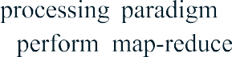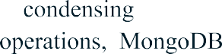





# 







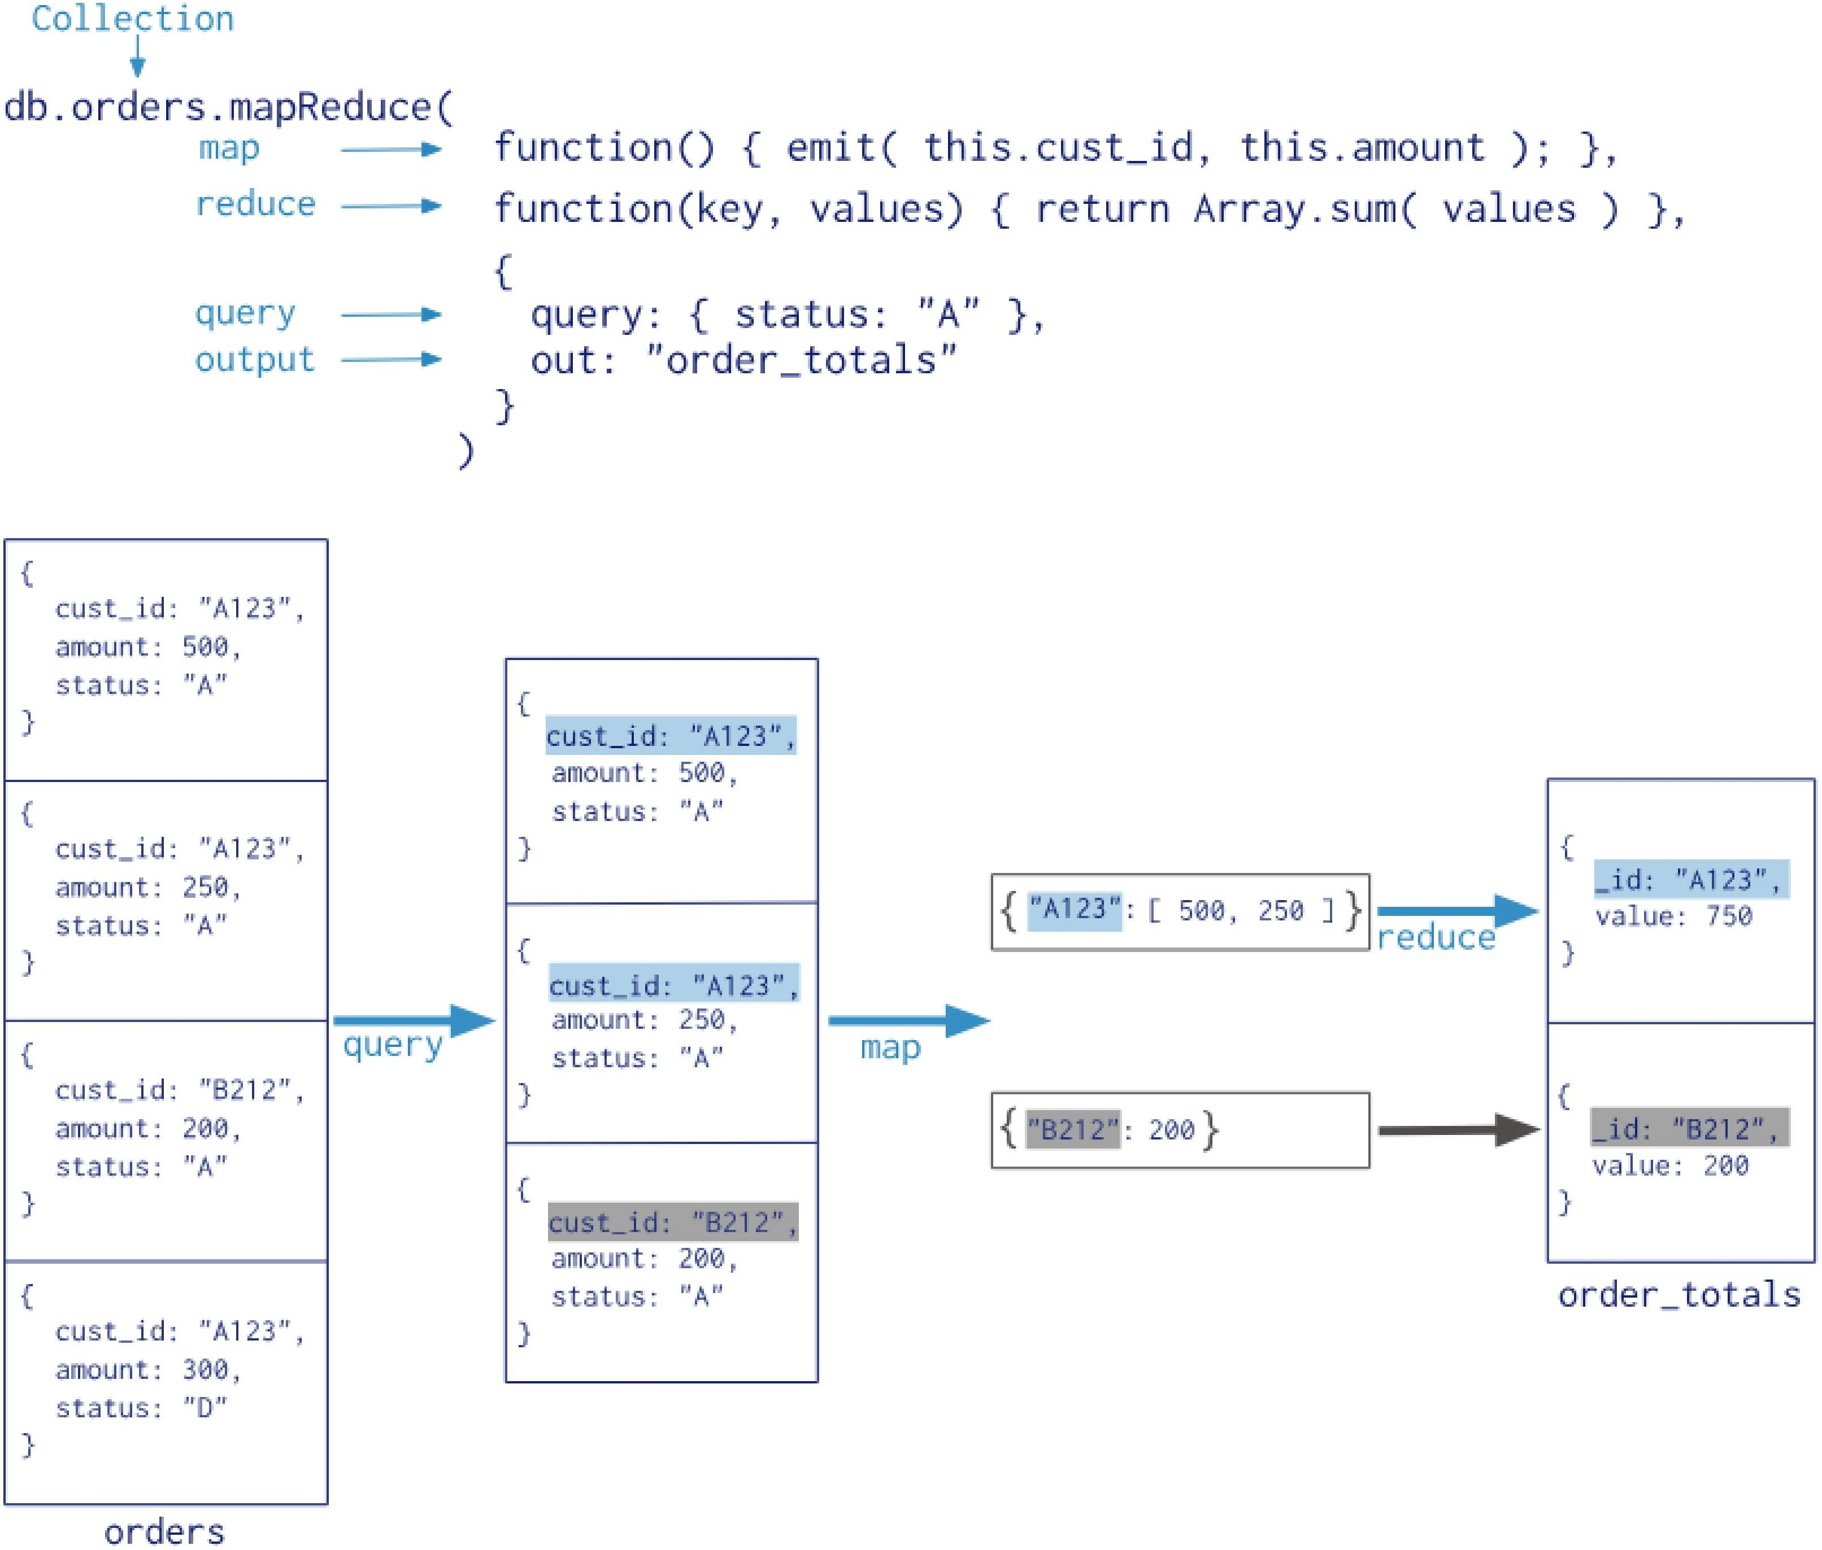





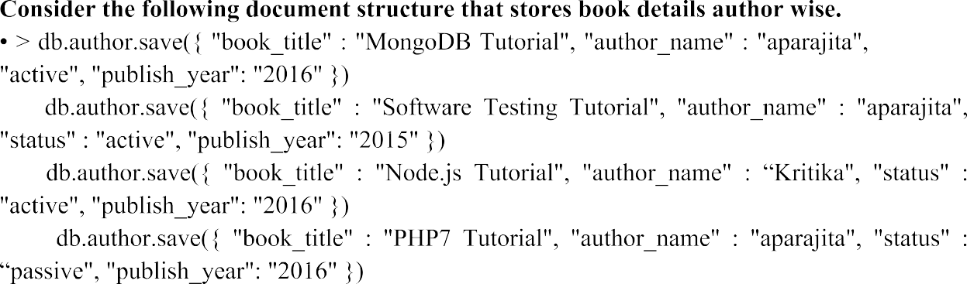







































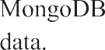         



# 

# **Write the MapReduce Program to calculate the total marks secured by each student in all subject**

# 

# 